Strategic Fundamentals and Environment Plan for Business Upstart

Introduction

This is a strategic fundamentals and environment plan Dutch Brothers Plus upstart. The community of Marysville formally known as Linda California suffers from financial oppression. The general mindset is one of poverty and lost hope. In fact according to Factfinder.gov over 32% of the seventeen thousand people are impoverished (FactFinder, 2018). It is not that people are not making money as the median household income of those that do work is 37k a year (FactFinder, 2018). In addition, current efforts of the city are aimed at rejuvenation. Currently, the sidewalks, drainage, and new roads are all being installed. It is our belief that the propose upstart will be steps toward a community transformation on more than one front. First it will bring people of vision out from the college. People on a track to success can shine a light in the darkness of financial oppression. Secondly, this will provide a needed gathering spot, that is quiet and professional for student to meet and study. Thirdly, by being a hybrid and offing a health juice-based drinks the upstart will magnify health and a healthy lifestyle in the community. Lastly, the closest coffee shop is in the city of Marysville, quite a drive for a coffee beverage, and the closest juice bar, Jamba Juice, is two cities away.

Role of strategy

The positioning of the new business will increase in value as time goes on. The strategy for increased value has been proven through both Starbucks, Jamba Juice, and Burger King. Starbucks has made clear the importance it awards the planet in creating it’s environmental mission statement: “Starbucks is committed to a role of environmental leadership in all facets of our business,” (Starbucks, n.d.). Some may feel that a coffee house cannot be environmentally conscience, however, it is our feeling that environmental impact begins with a firms goals. Jamba juice includes this statement in both its vision and mission statements, “To inspire and simplify healthy living.” We believe that health is a great motivator for success. Oppression ministers sickness, addiction, hopelessness, and many other unwelcomed community and environmental problems—people just stop caring about their community and their future and get lost in despair. Promoting health and education are in direct opposition to hopelessness. We also plan to adopt Burger Kings strategy for success in location by stealing the slogan, “through the light and to the right”. By choosing a four way stop light hindrances in stopping for a drink will be addressed.

Techniques

Techniques used to formulate positioning are within the steps that will be necessary to develop this new businesses strategies.

1. Environmental scan.
2. Do all analysis for business.
3. Clarify target customers, value proposition, and culture and cultural strategic advantage
4. Select staff choosing the correct skills and capabilities., choose teamwork goals, leadership style, and work climate.
5. Solidify and select the competitive advantage style, vision, and mission statements.
6. Formulate and establish performance measures, scorecard, and benchmarks.
7. Set goals and milestones.

Industry analysis

Jamba Juice is reporting about 75 million in revenue with 22% of that being the EBIT or about 15 million (Jamba. 2018). Dutch Brothers coffee is running head to head with that (Dutch, 2018). The over all state of both industries is good. Juice bars are showing a 2 billion dollar revenue with a margin of annual growth at about 2.3% (Juice, 2018). The coffee industry continue to boom with 37 billion a year and an annual growth of 3.6% (Coffee, 2018). The up coming generation is green, health conscience, and innovators. This means the forecast for both the coffee industry as well as the juice bar industry is one of promise. By creating a hybrid shop that sells both healthy juice and coffee the firm can expect growth in the area of the mean of the two which is nearing 3%. Suppliers for coffee are everywhere. This firm will both roast its own beans – mostly for the aromatic reasons, and purchase from suppliers pre-roasted beans. For juicing locally grown organic fruits and veggies will always have preference, then non locally grown organic. Only in emergencies will non-organic fruits and veggies be used. We expect about 30%--50% of the clientele to come from the college. However, the road to which the firm is located is also a major inlet to the local air force base. As a result, we expect that service personel will be a major portion of those who visit the establishment drive thru. Last but not least, are people going to work, or dropping kids off at one of the schools nearby. Currently, the only competitor is in the campus cafeteria. This is not accessible to neither the service personnel nor those going to work. The only other competition is downtown Marysville for coffee, and two cities away for Juice.

Analysis

SWOT What are the strengths, weaknesses, opportunities, and threats for this business***? Included a graphic as a visual summary. Microsoft Word “Smart Art” has templates that may be used***.

Dutch Brothers -------- Jamba Juice

Strengths:

Customer Service: Very friendly and affordable. Customer Service and Music

Positive Brand image Positive Brand Image

known for Community Involvement Known for good health

Gives back 1% to the community Buys local produce

Market entry costs are low Market entry costs are low

Weaknesses

Limited Merchandise No hot drinks for cold weather

Is not a Franchise only fresh produce

Drinks are limited limited customer base (health)

No Seating. No franchises available

Opportunities:

There is a great opportunity in the merging of these two industries. Weaknesses such as limited drinks and no drinks for cold weather are eliminated. Seating problems are also fixed along with limited customer base. The franchise issue is meet by not adopting the Jamba Juice franchise but instead just adding it under the current Dutch Brothers brand with the plus. This further allow the firm to adopt much of the Starbucks relaxed feel for those who wish to study, or commune. Another opportunity is cross promoting merchandise. The Healthy Coffee house can promote health and serve caffeinated drinks, both cold and hot beverages with a unique listing of menu items to eat. The last opportunity comes from the fact that there is neither a local coffee house or juice bar other than on the college campus. The cafeteria on the campus is always rumbling, busy, and loud. This startup will offer an alternative that is close enough to the college to be a desired destination.

Threats.

* While the firm is unique it is easily reproduced, and entry costs are low.
* A change in economy might cause people to stop spending on unnecessary drinks.
* Market entry without an existing brand would be difficult.
* Transportation cost for fresh fruit would vary with fuel costs.
* There is an upswing in home juicing, and home expresso that are cheaper alternatives
* Major supermarkets supply bottled juices and cold coffees, and both Food Max, and Walmart are nearby
* The Campus has a Starbucks vender in the cafeteria.

VRIO

Two more tools for internal analysis are the value chain and VRIO tools. The value chain dissects the organization and then identifies areas of unique strength or weakness but since we just performed a SWOT.

VRIO

Value chain functions are also called capabilities. VRIO—which stands for Value, Rarity, Imitability, and Organization—is a framework that advocates that a capability, or a resource, such as a branding or a great location, is likely to yield a competitive advantage. An organization shown to be valuable, rare, difficult to imitate, and supported by the organization create competitive advantage. When looking at Dutch Brothers Plus (DBP) there is definite value seen through VRIO analysis.

Value: First people love their coffee, and they also love a place to relax. Value is found in this area, however, Dutch Brothers Coffees add value by offering beverages at a discount when compared to Starbucks, or Java Detour. In addition, streaming music is a cornerstone of Dutch Brothers Coffees that DBP will continue. Music partnerships with companies such as iTunes have proven to create value already by StarBucks. Jamba Juice creates value by cornering the market on the health front. Healthy, organic juice is a great supplement for coffee and a great alternative to soda pop. DBP plans on continuing creating value through great service that has both quality and friendliness.

Rarity: DBP is very rare in that it is a hybrid coffee house and a juice bar. In addition, it is rare because there are no other juice bars within the city, to add the closest coffee house is in downtown Marysville.

Imitability: This business is easily duplicated. While this is a negative if another entrepreneur where to start one in competition it is also a positive for producing carbon copies in other location as the firm grows. One the other hand, this business supply chain and SCM system will be costly to reproduce. There are only so many fresh organic fruits and vegetables grown locally and since DBP is the first of its kind it will have a strategic advantage through new product development. Further, using Porter's Generic Competitive Strategies there is a competitive advantage from being a cost leader as well as having differentiation.

Organization: DBP must organize its management systems, policies, organizational structure, processes, and culture to fully realize the potential of its valuable, rare and costly to imitate resources and capabilities. This will come through Total Quality Management, Blue Ocean, and flexible product line.

PESTEL

Two primary tools examine the external environment for firms 1. PESTEL and 2. Industry Analysis. PESTEL is an acronym that stands for Political, Economic, Sociocultural, Technological, Environmental, and Legal environments.

Political:

Economical:

Socialcultural:

Technological:

Environmental:

Whereas PESTEL provides you with a good sense of the broader macro-environment, industry analysis informs you about the organization’s competitive environment and the key industry-level factors that seem to influence performance.

Notes Business, Dutch Brothers Plus Marsville.

Vision Statement.

Here, at Dutch Bros we live by three main core values. One cannot be sacrificed for another. All must work together in order to provide the best experience possible. We may be a coffee company, but we are in the relationship business.

Jamba juice

to inspire and simplify healthy living

SPEED

Mission Statement

Dutch

Love Abounds and Dutch Bros are both about people first. Dutch Bros has established Love Abounds to actively engage its communities through giving and action. Love Abounds supports programs and projects that build deeper connections through engagement in Four Core Areas. Youth Music Health Origins.

Jamba Juice

OUR MISSION: To become the world's leading blender of fruit and other naturally healthy ingredients. Part of what makes Jamba Juice so successful is the passion both our customers and employees share for the product. ... OUR TIMELESS PURPOSE: To inspire and simplify healthy living.

SMART (specific, measurable, attainable, relevant, and time-bound) goals. Just like a SWOT (Strengths, Weaknesses, Opportunities, and Threats) Analysis, SMART goals need to be in the toolkit of every businessperson. Therefore, you will see SMART goals and SWOT analysis in several competencies as they apply in this program.

Organizational performance refers to how well an organization is doing to reach its vision, mission, and goals.

Two important considerations are (1) performance measures, and (2) performance referents. A performance measure is a metric along which organizations can be gauged. A performance referent is a benchmark used to make sense of an organization’s standing.

balanced scorecard. The balanced scorecard is an approach to assessing performance that targets managers’ attention on four areas: (1) financial, (2) customer, (3) internal business process, and (4) learning and growth.

Financial measures of performance relate to organizational effectiveness and profits. For example, Starbucks’s 2009 annual report highlights the firm’s performance in terms of net revenue, operating income, and cash flow over a five-year period.

Customer measures of performance relate to customer attraction, satisfaction, and retention. Starbucks realizes the importance of repeat customers and has taken a number of steps to satisfy and to attract regular visitors to their stores. For example, Starbucks rewards regular customers with free drinks and offers all customers free Wi-Fi access (Miller, 2010). Starbucks also encourages repeat visits by providing cards with codes for free iTunes downloads. The featured songs change regularly, encouraging frequent repeat visits.

Internal business process measures of performance relate to organizational efficiency. Organizations such as Starbucks realize the importance of such efficiency measures for the long-term success of its organization, and Starbucks carefully examines its processes with the goal of decreasing order fulfillment time. In one recent example, Starbucks efficiency experts challenged their employees to assemble a Mr. Potato Head to understand how work could be done more quickly (Jargon, 2009)

Learning and growth measures of performance relate to the future. One way Starbucks encourages its employees to learn skills that may benefit both the firm and individuals in the future is through its tuition reimbursement program.

Measuring Performance Using the Triple Bottom Line. the triple bottom line emphasizes the three Ps of people (making sure that the actions of the organization are socially responsible), the planet (making sure organizations act in a way that promotes environmental sustainability), and traditional organization profits.

In terms of the “people” dimension of the triple bottom line, Starbucks strives to purchase coffee beans harvested by farmers who work under humane conditions and are paid reasonable wages. The firm works to be profitable as well, of course.

Business-level strategy addresses the question of how a firm will compete in a particular global industry

A generic strategy is a general way of positioning a firm’s business-level strategy within an industry.

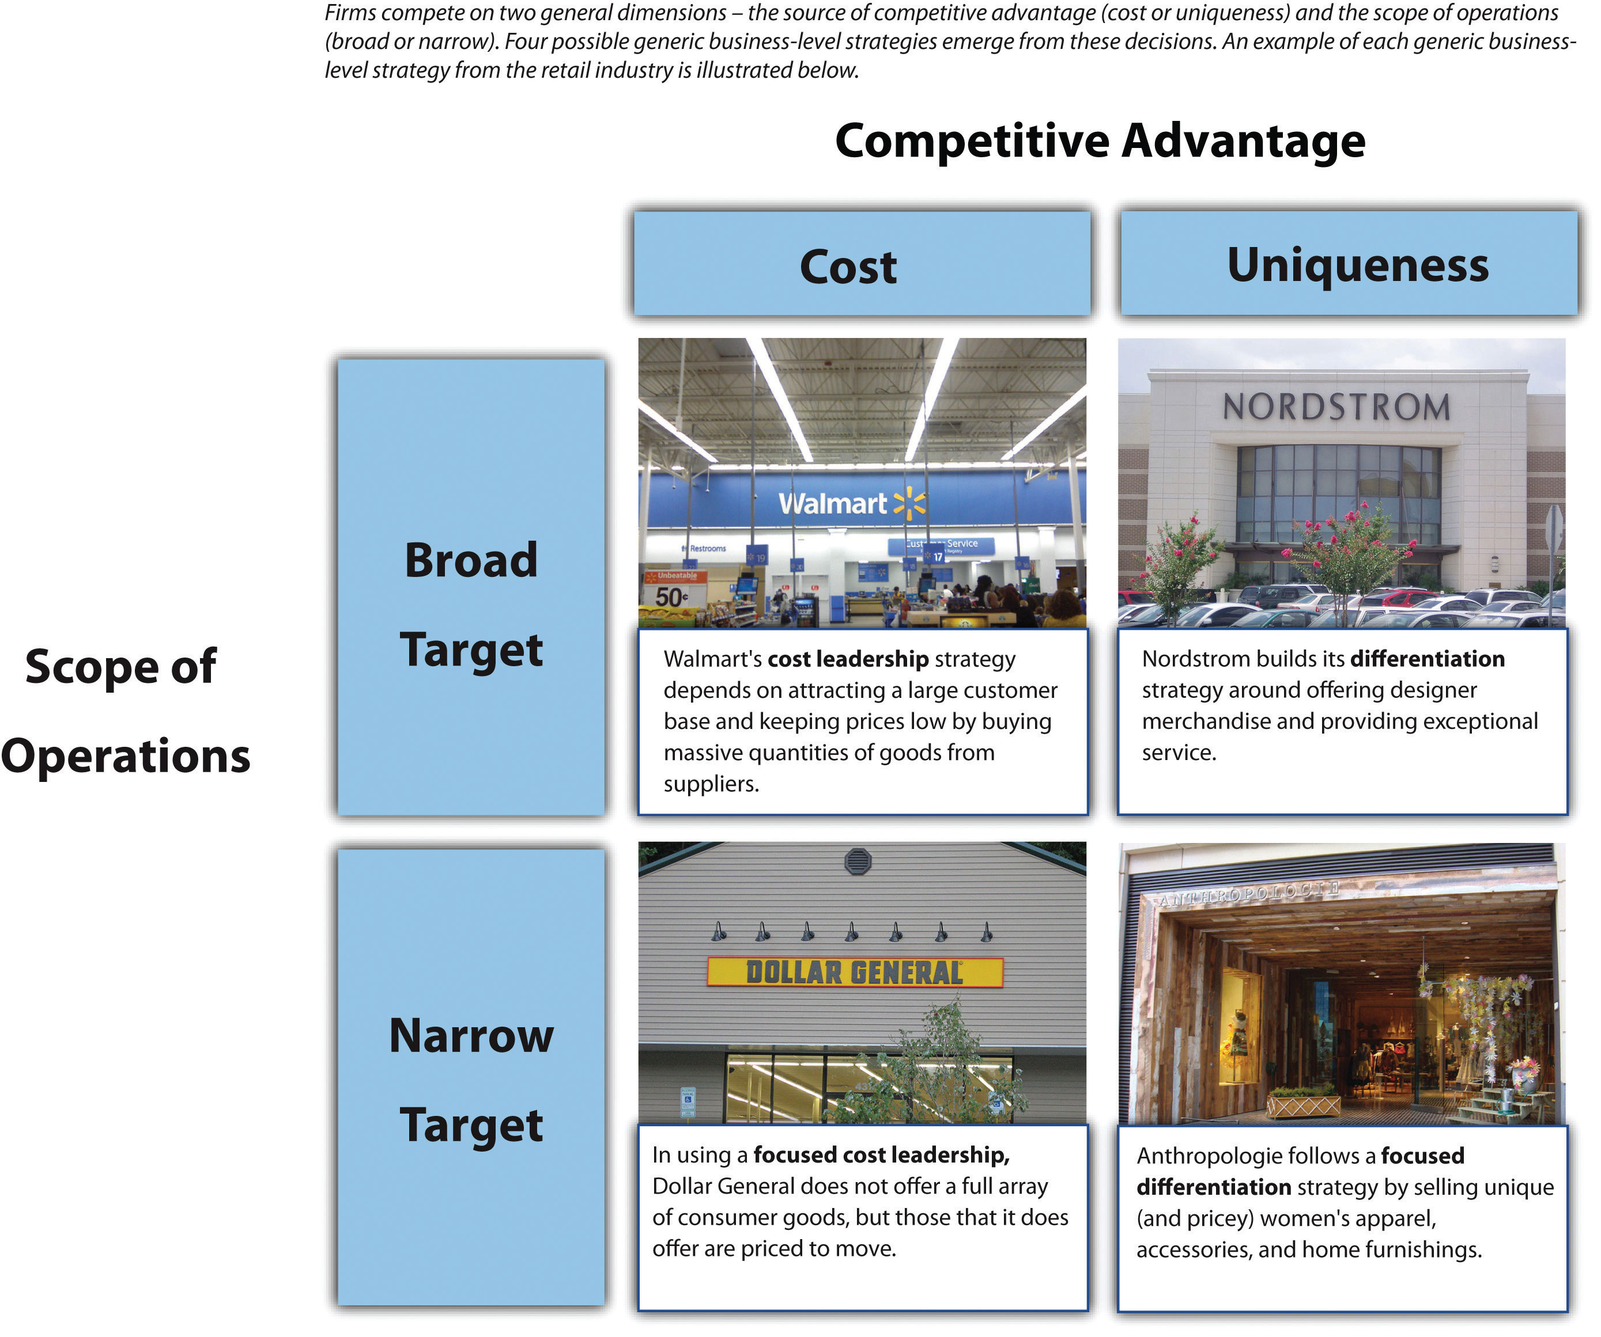

Four generic business-level strategies emerge from these decisions: (1) cost leadership, (2) differentiation, (3) focused cost leadership, and (4) focused differentiation. In rare cases, firms are able to offer both low prices and unique features that customers find desirable.

you will need to decide on a strategy to gain a competitive advantage.

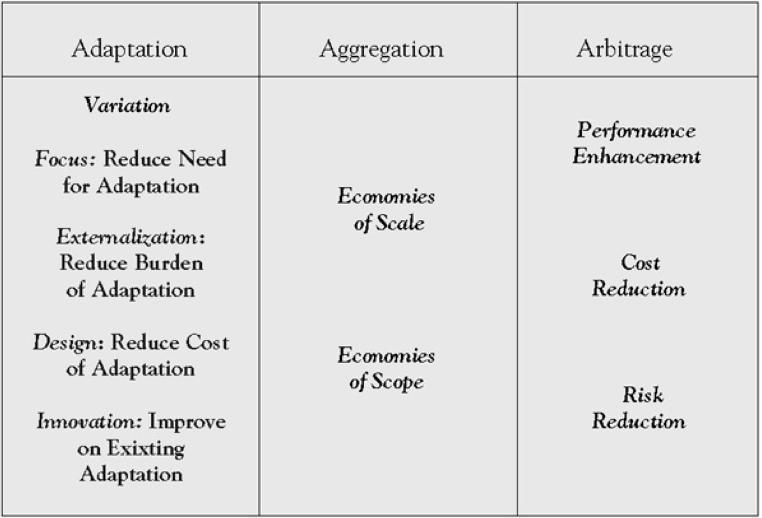

Select the core values of your business that will guide the behavior of your employees and explain how you will communicate it to your employees and encourage them to embrace it.

The community that I live in is financially oppressed, however, there is a college very near. One strategy to fight the oppressive spirit of the community is to get the students from off the campus into the community. The spirit of hope and destiny will be a welcome change to the environment. Since the college is so close the student have an untapped intrinsic value in the community.

• Do some research about the business you have chosen using credible, academic resources. You will include them as references in both the plan and PowerPoint, but also cite them throughout your analysis as supporting information for your proposal.

• Develop a plan for your proposed project to structure your analysis. You will need to write a clear and concise plan with about one paragraph for each of the following sections (and subsections):

6. Strategic-Planning Process: Discuss the following steps in the strategic-planning process:

A. How will you determine the organization’s mission and goals? How do you justify your organization’s mission and goals?

B. What are the strengths and weaknesses for your particular business?

C. Which one of the follows strategies from the competency will you implement for your particular business? Recall

the Porter’s Key Strategies and Ghemawat’s “AAA” Global strategies, including:

• Cost leadership

• Differentiation

• Focused cost leadership

• Focused differentiation

• Adaption

• Aggregation

• Arbitrage

D. How will you implement the company’s strategy? Recall the implementation strategies you read, including:

• Tactical

• Operational

• Contingency

• Crisis Planning

6. Financial Considerations: What are the financial ramifications related to your new business? How might your proposed strategy impact current leadership structures?

7. Organizational Structure: How could the organizational structures reposition to promote innovation and creativity that would result in greater organizational effectiveness and efficiency?

8. Conclusion: Summarize the key points you have made in a single paragraph with clear, concise, positive, language.

Reference

<https://factfinder.census.gov/faces/nav/jsf/pages/community_facts.xhtml>

Dutch brothers <https://www.forbes.com/companies/dutch-bros-coffee/>

Jamba Juice <http://ir.jambajuice.com/phoenix.zhtml?c=192409&p=irol-newsArticle&id=2338420>

Juice <https://www.ibisworld.com/industry-trends/specialized-market-research-reports/consumer-goods-services/food-service-drinking-places/juice-smoothie-bars.html>

Coffee <https://www.ibisworld.com/industry-trends/specialized-market-research-reports/retail-market-reports/the-retail-market-for-coffee.html>