Chapter 2 Class notes.

Sacred monody:

1. Prelude; Psalms or praise .

Secular monody:

1. Courtly or popular
2. Elite and Traditional.

Both were used as entertainment or conveying feelings.

700ad thru 1500ad Crusades happened.

Liturgy.. the prescribes body of text. To be performed in religious service.

At the beginning most music in this time period was chant.

Office: the chants performed during regular hours.

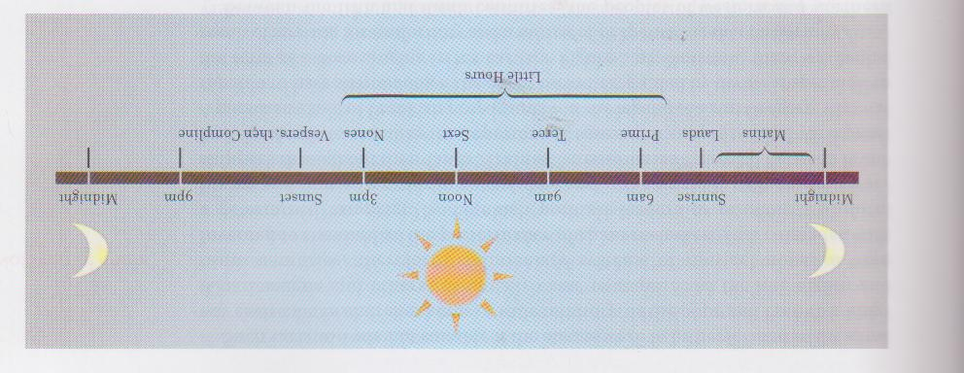

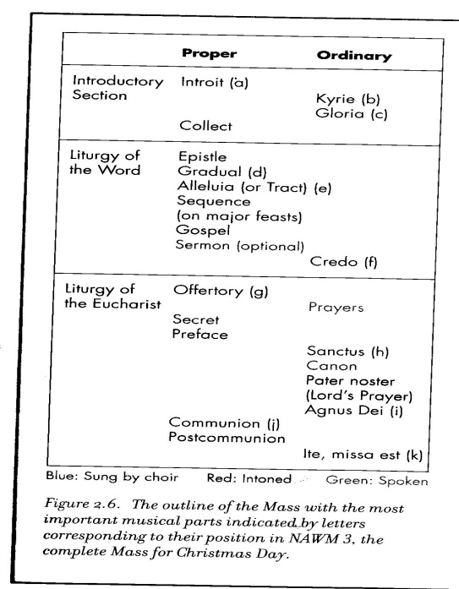 The canonical hours.

Mass. Celebration Service that has its roots in the Communion of Jesus Christ.

Matins and Vesper.

1. Matins are those chants performed from midnight to sunrise. We don’t get to hear it much because of the time.
2. Vespers are those chants at sunset. Vesper is almost like a Concert
3. These are Musically most ornate and Significant.

Office were the normal every day stuff

Proper are those parts that change according to day or event.

These types are attributed to **St Benedict**. **However, St Gregory** is the one that the dove came too and sang all the chants, after hearing them He wrote them down.. Most of the older chants are attributed to **St Gregory**.

St. Cicilia – is considered the Patron saint of music. Because while she was dying she sang to God. It is said that even at Her wedding she sang in Her heart to the Lord.

**Tropes**: add to the chant

**Melisma**: adds to the melody.

**Sequence**:Began from Alleluia. Often had long melisma that extend the emotion attached to worshiping God.

Of the listening selections on this chapter. Only Kerie is ordinary. The rest are all proper.

Introit --- Priest enters is Direct. Kyrie—Responsorial then direct Krista – Direct Kyria -- .

These were all sang three times for Father, Son, Holy Ghost.

Movies to Watch “Visions of Hildigard.” “the Pillars of the Earth”.

Akatin

Aquitanian Organum – The upper voice is moving.. while the lower voice is held steady. Lower voice is a tenor. Tenor means (to hold)

Motet.. tenor long note. Upper note goes against it.

Cantus Firmus .. important into the baroque period. But then changed.