Class notes chapter 4

With Early notation

Perfect = 3 inperfect =2, major =3, minor =2.

Perfect major. Is a Circle with a dot

Perfect minor is an empty circle.

Inperfect major is a half circle with a dot.

Inperfect minor is a half circle. This evolved into common C 4/4 time.

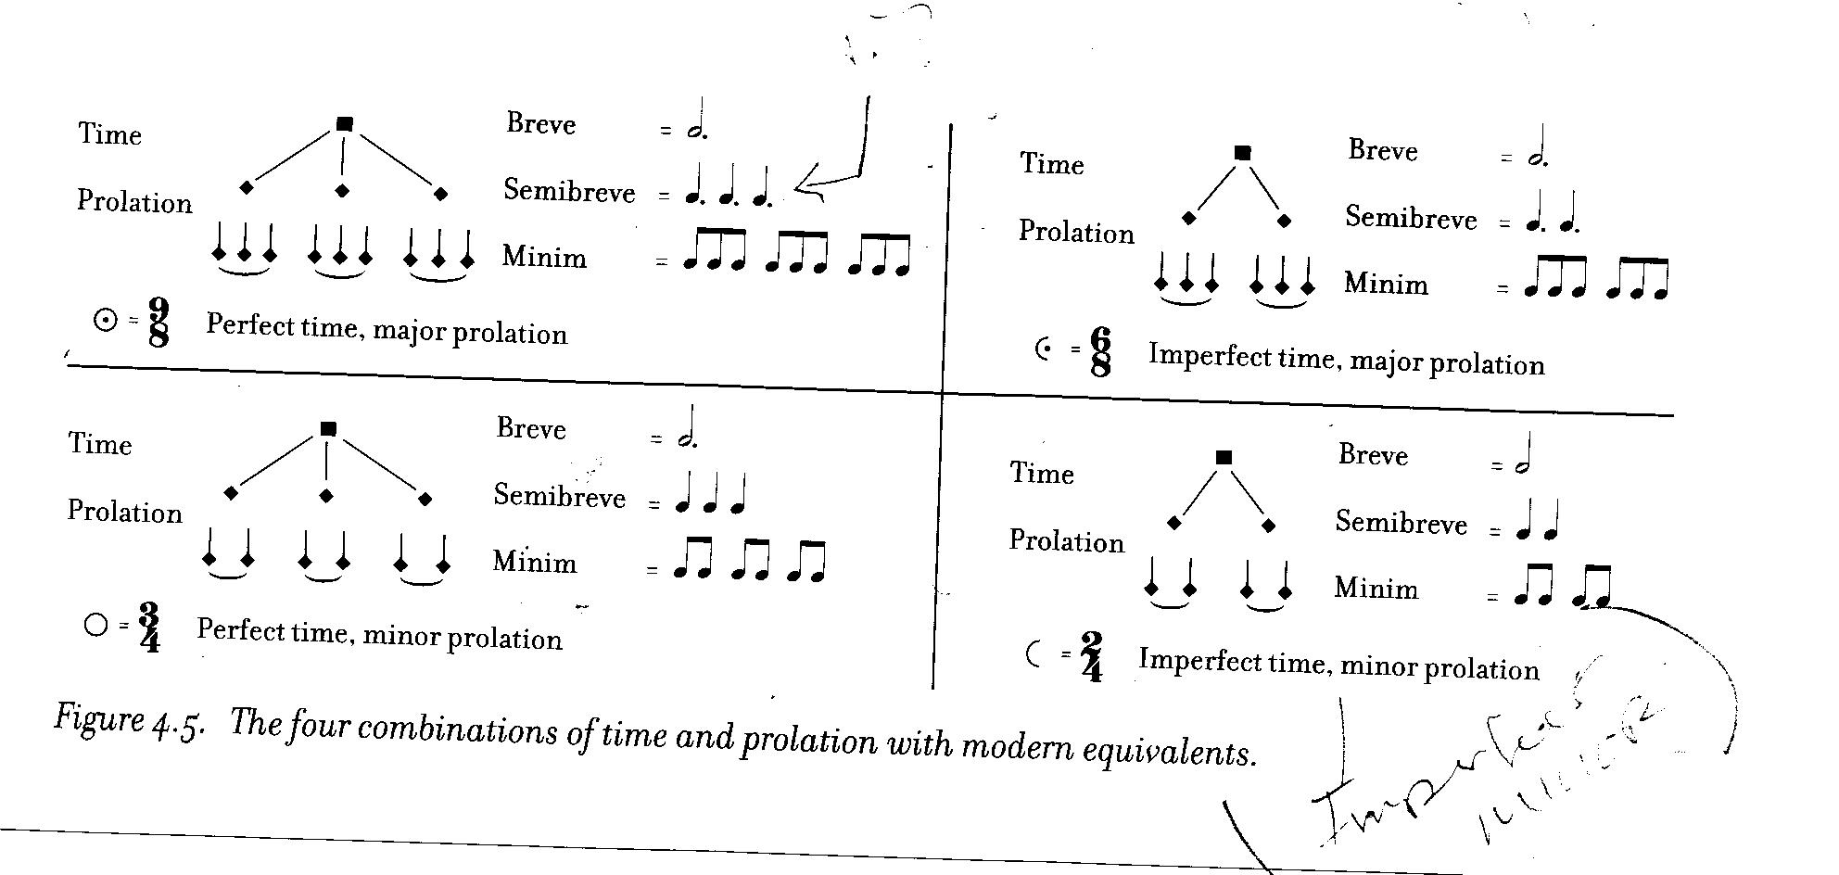

Form fixes (form fix) Poetic forms.

Schemes of poeted and musical repretition each with a refrain / stanzas. Especially the French chansons. They are durational aabbA. Not to be confused with the quiz, aabbC.

Virelai – (Verlay) doncedtoit., Ballade- (Ballad), Randeau – (Rondoo)

Italy had their own music which had nothing to do with the french just the name is similar.

Ballata – Dance,, Migdrigal – two voices without instruments.,, Caccia –Very Strict. Means chasing or hunt. An example of caccia is row row row your boat, how each part comes in after the next.