Class Notes Chapter 5

Age of the Renaissance

1. great change.
   1. 1855 History de Grance by jules michelt. Coined the phrase renaissance.

Renaissance means rebirth. And aims to restore:

1. Learning 2. Ideals. 3. The values of ancient Greece and Rome. Partly by the study of ancient writings now made available through the printing press.

Now technologies include

1. Oil painting. 2. Printing press. New ways to read and understand the bible.

No single event inaugurates the renaissance. Look at the time line.

Renaissance began in Italy.

Europe in the Renaissance.

1. End of the hundred year war. 2. Fall of Constantinople. 3. Rise of Europe as a world power.

Economy & Society.

1. Europe prospering from Trade. 2. Through growth of this time the social and economic foundations for the renaissance. 3. Translations of Greek scholarly writings to Latin.

Humanism—a fall for mankind from God.(my own belief)

1. Is the study of humanities and things pertaining to human knowledge.
2. These include Grammar, Rhetoric, poetry, History, normal philosophy, classical Latin and Greek writings.
3. Improve our condition by our own efforts.

Renaissance and architecture.

Donatello— His sculpture of David was the first nude sculpture since roman times. This sculpture was to be a celebration of the beauty of the human form.

Humanism. The pupose of showing the world as it is and the beauty of the human body. The term HUMANISTIC is also a parallel in music.

1. Composers sought to please the ear with sonorities and smooth melodies and rhythms.
2. A perspective of representing 3 dimensional space on a flat surface.
3. Humanism Characteristics are those attempting to portray the individual faces, bodies, and poses and attire.

Humanistic Music Parallels. By using separate lines of polyphonic music.

1. They started studying music again (Ancient Greek) Because they frlt that music had lost the power it had. According to ancient Greeks music could heal you or make you sick, it had enormous power.
2. The study of modes, however, the modes that they had and thought to be ancient Greek were actually just the modes that were made in the church.
3. Through modes words in music became very important, so the phrase began to be clearer.
4. The term Text Painting—is causing the melody to move in a way that reflects the words.
   1. If the text says running up a hill, the music goes upward. Etc.

Musical Renaissance.

1. Musicians reflected humanism in different ways.
   1. Increased Support for music.
   2. Careers of musicians changed greatly
   3. Chapel members served as performers, composers and scribes.

Trainings desires.

Tinton. Liber de arte counter. Book of Art of counter point.

Zarboo; le institution harmony.

1. Medici – the leading family in Florence. They supported. Into Banking
   1. Heinrich Isaac.
   2. Jacques Arundel
   3. Donatello
   4. Botticelli
   5. Michael Angelo.
   6. Cosmopolitan Musicians.

Duy Fay is known for sacred music and Binchios for Secular bvut both wrote both.

Different types of Masses.

1. Merchout – cyclic mass pg 103
   1. Barrow tenor barrowed from the other piece of a cantus firmus.
2. Motto -- Head motive.

**Know the Motet guide on page 99**

Anthem – Song that has 4 polyphony that is sacred, a little different then a hymn.

1. Sacred ????Something comes from a motet style. And means it is a polyphonic piese on sacred text.
2. In England it means its English. The church of England came about because the Pope in Rome wouldn’t give a divorce to the King. So the king made the church of England.

The Terms Motets and Anthems became synonymous in the 1500s.

Joasquin Perez was on the same level os Michael Angelo musically.

Fauxbourdon -- French for imitations. Pg 101

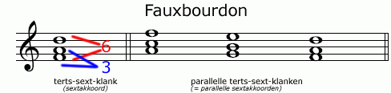

The last inversion.

English tradition of having the 3rd. are moving into the more triadic Sound.

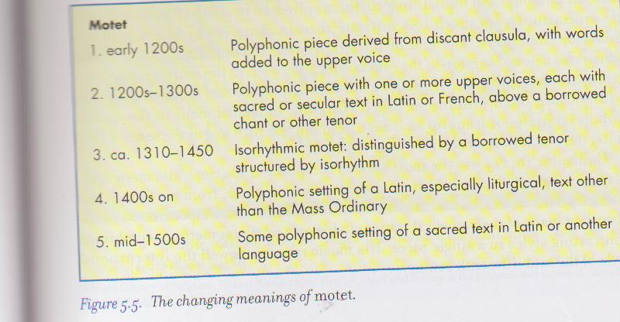De plus un plus (da plue Zan plue) Chanson in Rondau form by Binchous. Later Ockeghenm wrote a whole mass based off this isorhythmic as is all the fashion at this point.

Homorhythmic – move in the same rhyhm

Homophony – melody and harmony

Polyphony – different lines , can be homorhythmic.

Quanplukn esk. In this the text is out of song of Solomon.