Class notes chapter 6

Renaissance is the study of old text from Greece and Rome.

In the new tunings 3rds and 6ths are used.

Humanism: the people didn’t; have to right wars, the wars were now fought by mercenaries. They were free and though they went to church and prayed they gave priority to earthly matters. Personal fulfillment through education, public service and accomplishment motivated their lives as well as there social contacts and institutions.

Three types of canons in this chapter

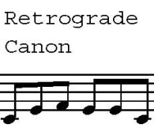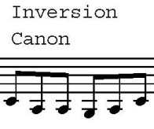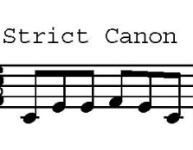The strict canon… the inversion –upside down… the retrograde canon – Backwards canon

The misuration –moving around at different times.

Form fixes. Verili, rondau, ballad. Of which only rondau is really continuing.

They turn strophic.

Cyclic Mass – different parts are musically related.

Types of Cyclic masses

Masses with barrowed material.

1. Countus firmus mass --Cantus firmus – single voice chant or leading tenor voice.
2. Parady mass – All voices used and transfer, Polyohonic work that is already constructed, then re-written.
3. Paraphrase mass –A single melody is used, typically a well know melody. All voices are used.

Other masses

1. Motto mass – mass with the same head motive in every section.
2. Canon mass – basses on a specific set of rules.

P 123

Petrucci – famous for printing music parts. (books with one part of a harmony) His were expensive but the printing quality was very nice.. he use a 3 layer printing technique. However, eventually the common printing ended up being the less expensive type. Nowhere near as nice but affordable.