MUS8A: Music History Study Guide for Test 2

What is covered: Part Two Introduction. Chapters 5 8
Put Kyrie and Credos side by side be able to tell them apart.
Note which ones are for keyboards.
Find a way to Identify Masses apart. Listen to similar ones find differences.
Madrigals: Separate into three classes. Early, Middle(txt painting) and Late(chromatic).

What to study:
- Your notes on the lecture from the classes
- Notes you took on the textbook reading
- Timelines
- Outlines on Study Space website (www.wwnorton.comlmusichistorv)
- Listening Selections. Chapter Quizzes and Flashcards on Study Space

LISTENING
- Sumer is icumen in (a medieval rota) Singing Cu cu. Rota(latin for Wheel) goes round. Cannon.
- Quam pulchra es (motet) by John Dunstable
- De plus en plus (chanson-rondeau) by Binchois
- Se la face ay' pale (chanson-ballade) by Guillaume Du Fay
- Christe, redemptor omnium (hymn fauxbourdon style) by Du Fay
- Kyrie from Missa prolationum (canon mass) by Jean de Ockeghem (early 15th cent)
- Kyrie and Credo excerpt from Missa pangelingua (paraphrase mass) by Josquin des Prez(clear)
- Mille regretz; (chanson) by Josquin des Prez
- Mille regretz; (lute intabulation Ch. 7) by Luys de Naravaez
- Ave Maria ... virgo serena (motet) by Josquin des Prez
- Lo non compro piu speranza (frottola) by Marco Cara
- Da Ie belle contrade d'oritente (madrigal) Cipriano de Rore
- Solo e pensoso (madrigal) Luca Marenzio
- "lo parto" e non pui dissi (madrigal) Carlo Gesualdo
- Cruda Amarilli (madrigal) Claudio Monteverdi
- Tant que vivray (chanson) Claudin de Sermisy
- My bonny lass she smileth (madrigal ballet) Thomas Morley (fa lala refrain.)
- As Vesta Was (madrigal from The Triumphs of Oriana) Thomas Weelkes
- Flow My Tears (air / lute song) John Dowland (Lute Accompaniment.)
- Pavana Lachrymae (stylized dance for keyboard. variation of a lute song) William Byrd.
- Oy comamos y bebamos (villancico) Juan del Encina. (Spanish.)
- Canzon septimi toni a 8 from Symphyoniae ,sacrae (instrumental canzon) Giovanni Gabrieli (st marks in Venice)
- Ein feste Burg (chorale) Martin Luther (in German)
- Or sus, serviteurs du Seigneur. Psalm 134 (metrical psalm) Loys Bourgeois(Calvinist) Psalter
- Credo and Agnus Dei from Pope Marceluls Mass (free mass) Giovanni Pierluigi da Palestrina
- O magnum mysterium (motet) Tomas Luis de Victoria
- Kyrie from Missa O rnagnum mysterium (parody mass) Tomas Luis de Victoria
- Cum essem parvulus (motet) Orlande de Lassus
- Sing joyfully unto God (full anthem) William Byrd

Guide to studying the listening selections:
- Read the passage in the textbook where the selection is discussed.
- Listen to the selection to aurally connect the explanation with the actual music.
- Identify the genre (type of composition), the approximate date of composition and the composer, if known.
- Identify the text source(s) and general meaning.
- Determine if the work is sacred or secular.
- Identify the typical situation when the work would have been performed. (When, where, who, how)
- Identify and understand significant characteristics and compositional techniques employed.
- Listen for the particular performing forces. such as number of singers, gender of singers, types of instruments used. etc.
- Listen for particular characteristics and snippets of texts that give clue for identification.
- Compare similar selections. such as all madrigals, all motets, etc. to identify unique element of
each.

TERMS TO KNOW Terms and Names Related to Historical Background
Renaissance Humanism
Donatello Michelangelo
Botticelli Leonardo da Vinci
Copernicus The Medici Family
Chapter 5 Terms
Countenance angoise Hundred Years War
Burgundy Rota
Motet(changing definitions) chanson
Burgundian style fauxbourdon
Cyclic masses motto mass
Cantus firmus voice part names
L’Homme arme’ isorhythm

Names to Know Chapter 5
Dukes of Burgundy (Philip, Charles) John Dunstable
Binchois (Gilles de Bins) Guillaume Du Fay

Chapter 6 Terms
Musical Humanism Ancient modes
Tenor Mass point of imitation
Parody mass paraphrase mass
Canon retrograde, inversion & mensuration canons
Imitation partbooks
Missa sine nomine chansons(changing features)

Names to Know Chapter 6
Heinrich Glarean Dodekachordon
Johannes Tinctoris Liver de arte contrapuncti
Gioseffo Zarlino Le institutioni harmoniche
Jean de Ockeghem Missa propationum
Ottaviano Petrucci Harmonice musices odhecaton
Josquin des Prez

Chapter 7 Terms
Frottola (pl. frottole) lauda (pl. laude)
Canzonetta balletto
“Fa-la-la” refrains sonnet
Madrigal madrigalism.
Lute song (air) through-composed
Tablature villancico
Chromaticism word of text painting
Chansons(16th cent.) consort
Functional dance stylized dance
Intabulation vihuela
Virginal pavane
Prelude, fantasia recercare variations or variation form
Canzona or canzon cori spezzati

Names to Know Chapter 7
Petrarch Torquato Tasso
Giovanni Battista Guarini Concerto delle donne
Jacques Arcadelt Cipiriano de Rore
Luca Marenzio Nicola Vicentino
Carlo Gesualdo Claudio Monteverdi
Claudin de Sermisy Clement Janequin
Orlande de Lassus Musica transalpine
Thomas Morley Thomas Weelkes
John Dowland The Triumphes of Oriana
Juan del Encina Luys de Narvazaz
William Byrd Giovanni Gabrieli
St. Mark's Church in Venice

Chapter 8 Terms

Reformation chorale

Deutsche Messe Psalter

Old Hundredth Calvinism

Church of England(Anglican Church) Service(Anglican Music form)

Great Service Short Serivice

Full Anthem Verse Anthem

Counter-Reformation Council of Trent

Names to Know Chapter 8
Martin Luther Jean Calvin
Henry VIII Johann Walter
Thomas Tallis William Byrd
Giovanni Pierluigi da Palestrina Adrian Willaert
Tomas Luis de Victoria Orlande de Lassus

Further Study Guide
- Make a timeline and flow charts to keep people , ideas, and historical developments organized.
- Use flashcards.
- Connect terms, definitions, names and titles with actual musical example.
- Follow the stylistic development according to geography and compare differences by region.
- Compare sacred genre development with the secular genre development.
- Compare vocal genre development with the instrumental genre development.
- Compare melodic, rhythmic and harmonic styles of various composers as related to the timeline.
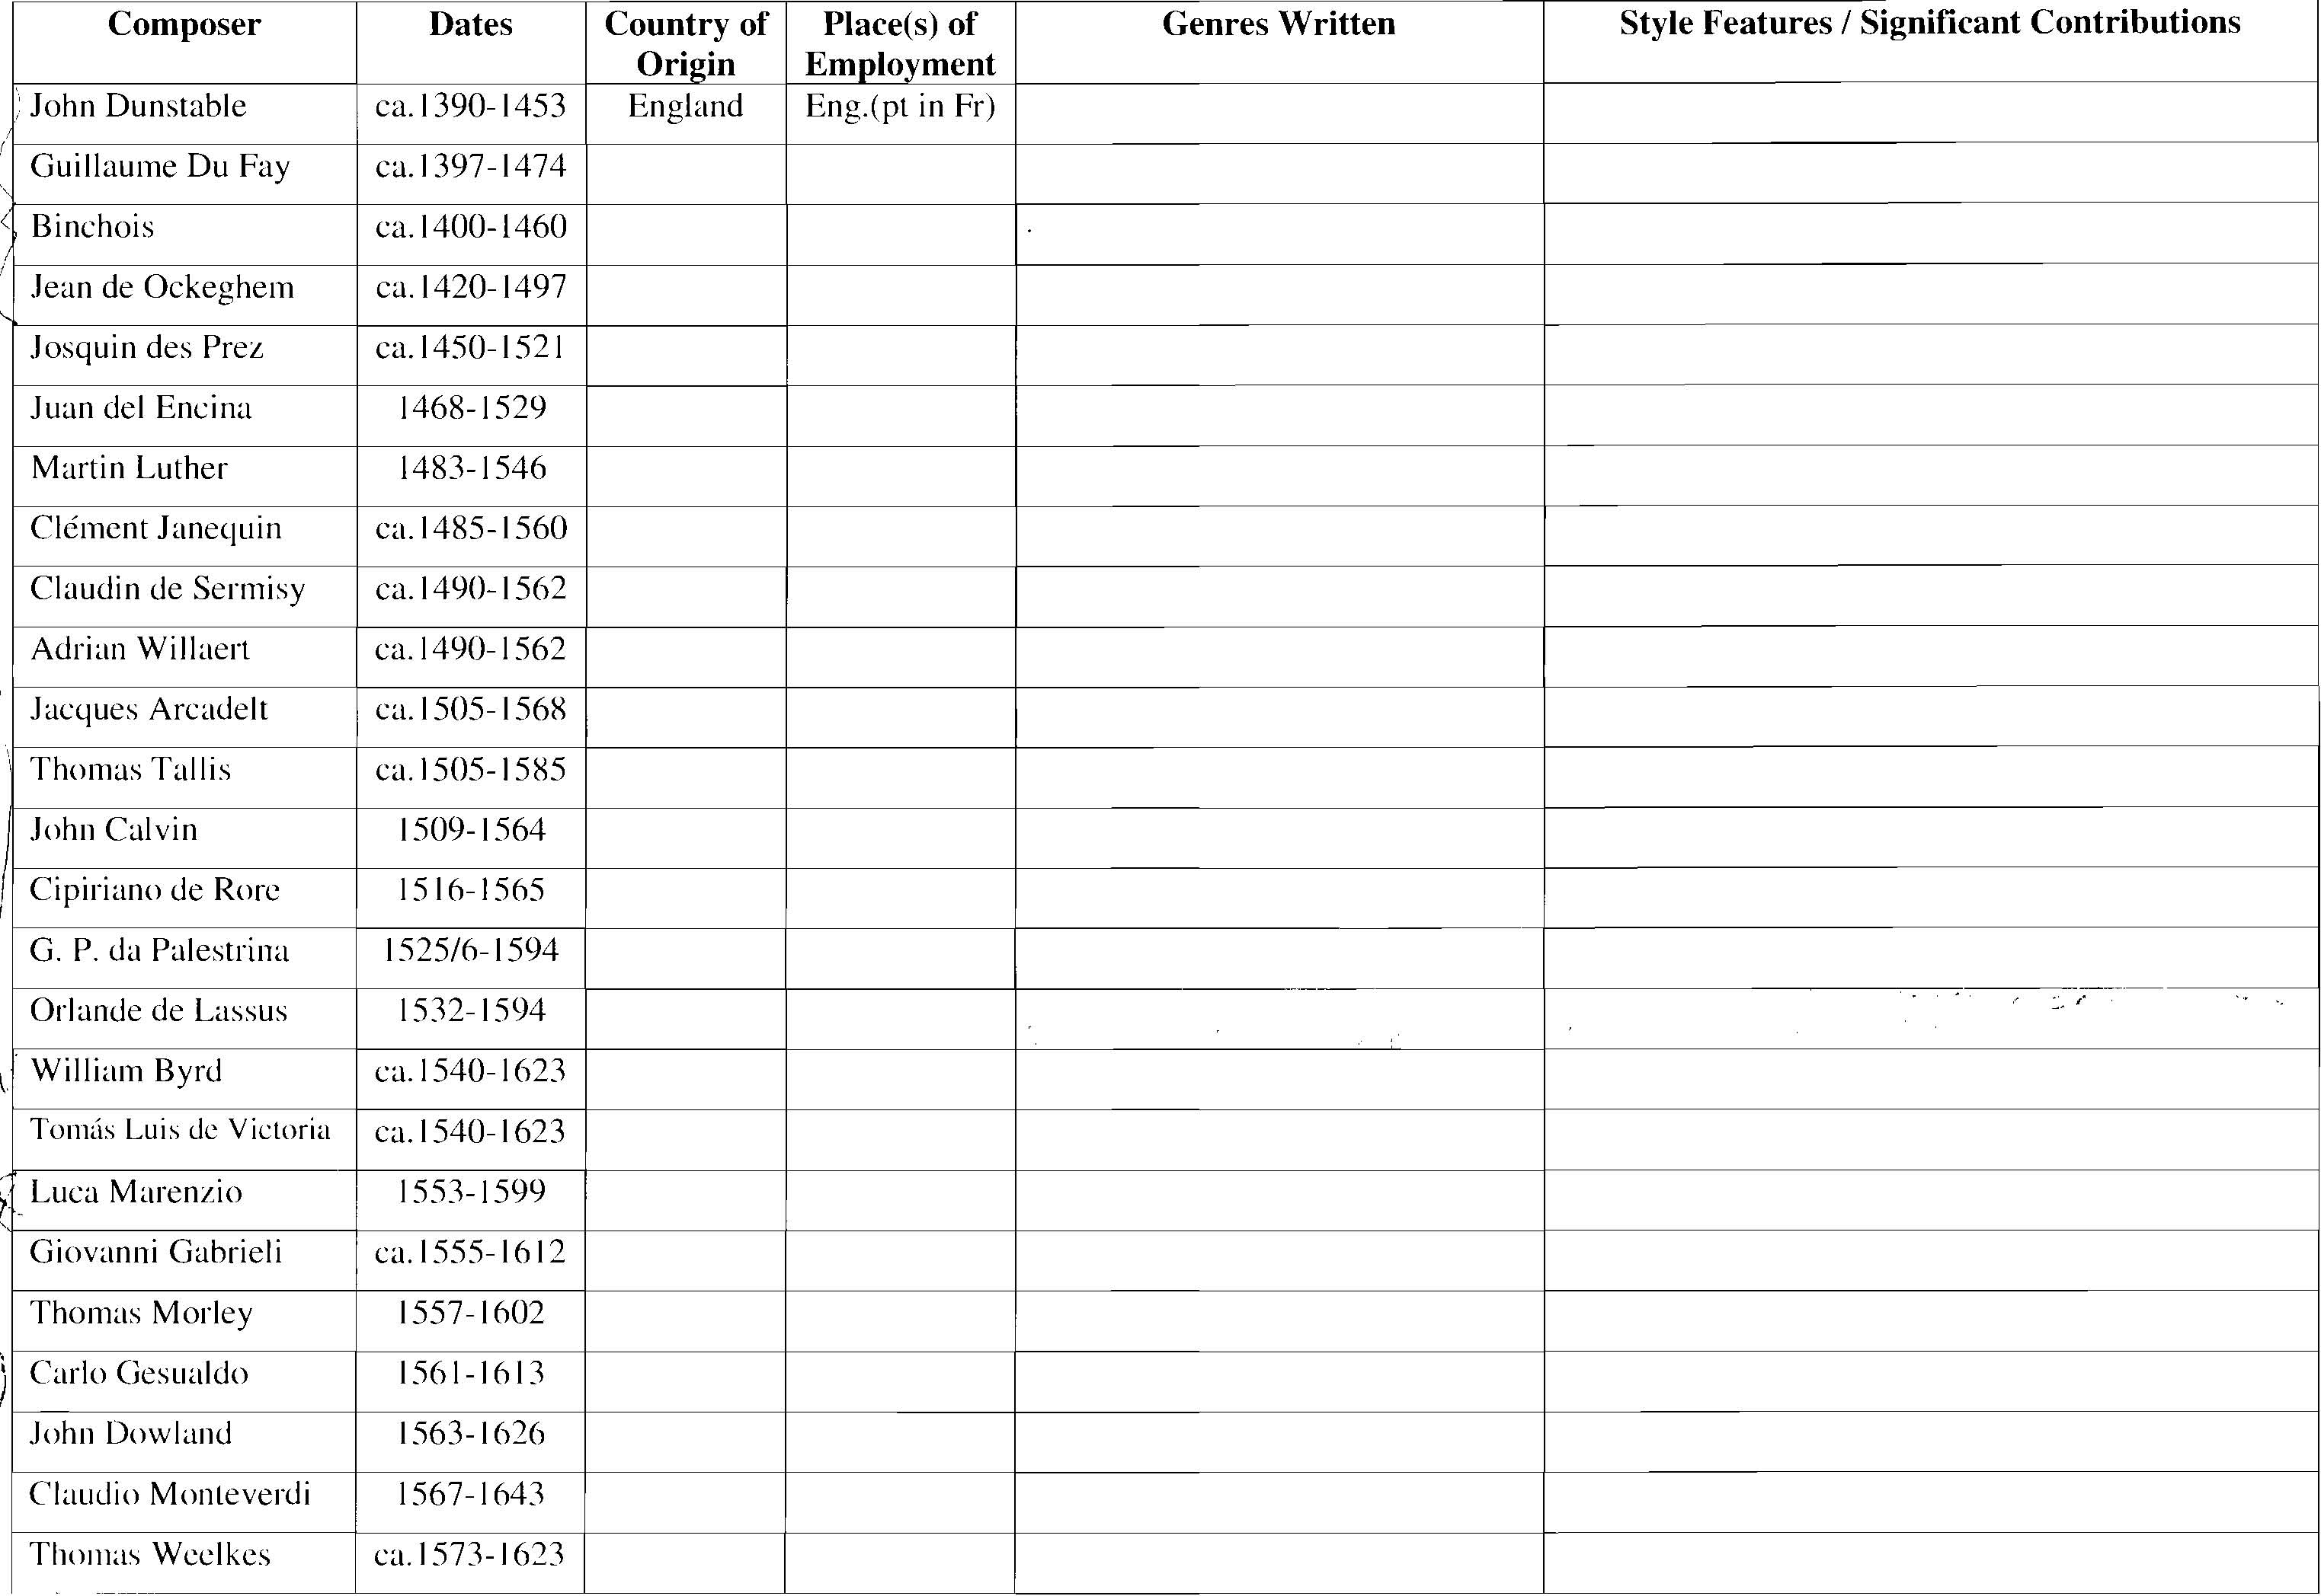
- Consider how historical background (economy, politics, religion, culture) influences the music.

